
 |  |  | 
 |  |  | 

Final report of the Specific Contract 2 (SC2)
Grid data Aggregation & Spatial smoothing modules
of the E-forest platform

“Framework contract for the provision of forest data and services in support to the European Forest Data Centre”
Reference: 2007/ S 194-235358 of 09/10/2007

Contents

1 The Framework context 3
2 The EFDAC E-forest platform 4
2.1 Objective 4
2.2 Description of EFDAC E-forest platform infrastructure 5
2.2.1 Overview 5
2.2.2 Software architecture 5
2.2.3 Layers provided by the JRC 6
3 EFDAC E-forest platform: Specific Contract 2 7
3.1 Main functionalities and goals 7
3.2 Database description 7
3.2.1 Overview 7
3.3 Modules description 9
3.3.1 “Harmonization” Module 9
3.3.2 Grid aggregation module 10
3.3.3 Spatial smoothing module 12
3.4 Difficulties encountered 14
3.4.1 Inland water 14
3.4.2 Inspire Grids 14
3.4.3 Interpolation performances 14
4 Follow up of the project, contractual steps 15

The Framework context

The objective of the framework contract is to broaden and develop the knowledge base of the European Forest Data Centre (EFDAC) hosted by the Joint Research Centre (JRC)1 of the European Commission which has been established to supply European Union decision-makers with processed, quality checked and timely policy relevant forest data and information within the EU and territories where EU policies are operating.
The EFDAC will be developed and implemented as the single and central point for forest information at European level in support to relevant EU policies and as the basis of the European Forest Monitoring System proposed in the EU Forest Action Plan. The implementation of EFDAC will contribute to enhancing data harmonization and to streamlining data collection and reporting to international commitments such as the Ministerial Conference of the Protection of Forest in Europe (MCPFE), the FAO Global Forest Resources Assessment (GFRA) and the UN Convention on Biological Diversity (CBD). EFDAC will be built on the basis of the information systems currently existing or under development and in compliance with the guidelines of the Infrastructure for Spatial Information in Europe (INSPIRE). In particular, these systems are the European Forest Fire Information System (EFFIS), the Forest Focus Data Platform, and the European Forest Information and Communication Platform (EFICP). New methods and tools developed for forest and natural hazards monitoring (forest fires, storms, etc) will decisively contribute to the further development and implementation of the Global Monitoring for Environment and Security (GMES) initiative.

Thus, the framework contract will include the provision of the following services or data at EU level:
- technical assessments such as reports, models, reviews, etc.
- data in the form of either statistics from forest inventory data (e.g. spatially aggregated plot data to provide harmonized estimates of selected indicators/attributes for given areas) or selected plot attributes derived from plot observation/measurements (e.g., forest type, growing stock), to be used as validation or training fields for map production or modeling..

Before providing these services, a platform called EFDAC E-forest platform is required.

The EFDAC E-forest platform

Objective
To provide the required services within the framework contract, a platform called “EFDAC E-forest platform” is needed. This platform is useful for all consortium’s partners to upload required raw data in response to a JRC request, harmonize them at an European level and transform them into aggregated data, spatial representation, maps, etc.
This platform can be considered as the central working area for the consortium’s members and acts as an intermediary system between the data providers and the EFDAC.

Under the framework contract, the first two Specific Contracts concern the building of EFDAC E-forest platform.
The first Specific Contract corresponds to the building of the EFDAC E-forest platform to perform raw data upload, storage and queries based on a central metadata base.
The second Specific Contract corresponds to an enrichment to run specific processes or perform treatments such as harmonization, aggregation, spatial representation, dissemination to EFICP.
The picture below shows the main modules by distinguish SC1(plain), SC2 (Hatched) and SC? for further developments.

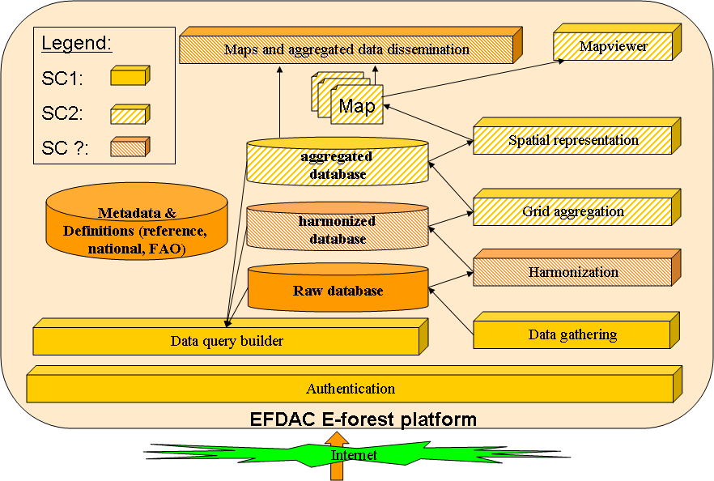
Figure 1: Consortium's platform modules

Description of EFDAC E-forest platform infrastructure

Overview

The EFDAC E-forest platform is developed by the French National Forest Inventory (FNFI) and hosted by the FNFI.
In order to reduce the cost of this platform, numerous modules come from other applications developed by the FNFI.
All the core or main components are based on Open source software.
The source code developed under this project is provided with the European Public Licence.

Software architecture
The following figure shows the software infrastructure

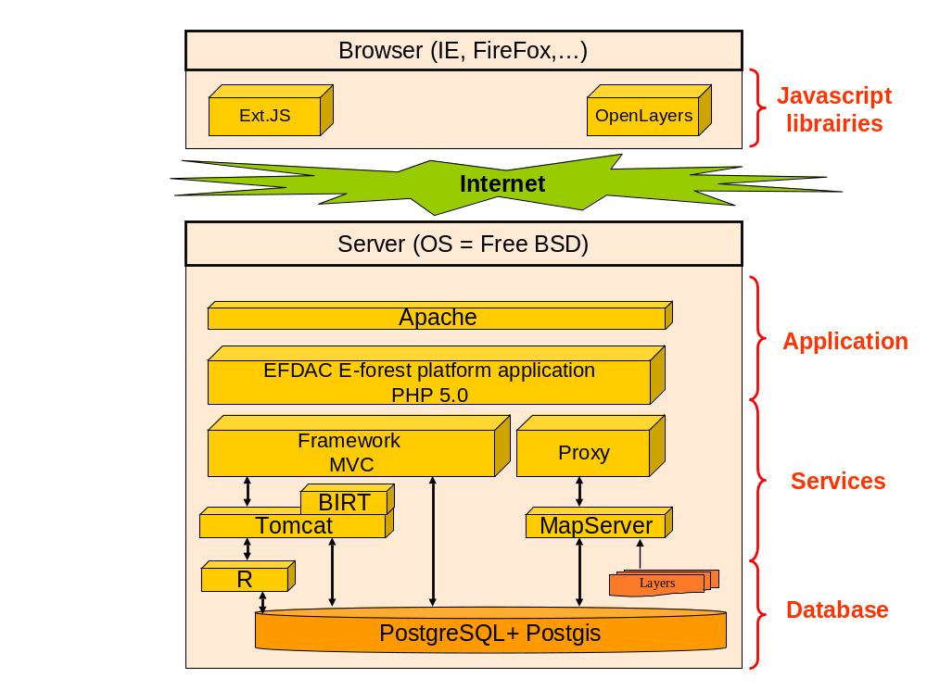
Figure 2: Software architecture

The server Operating System is Free BSD.
The web server application is based on Apache and Tomcat.
The application is developed using PHP and Java languages in order to be independent from the operating system.
PHP is a very mature and powerful language. PHP Web servers are robust and can be developed in a very short time.
A PHP framework is used to ensure the good respect of the Model View Controller design pattern which corresponds to a separation of the database accesses, the management of the user behavior and the web based user interface.
JAVA is useful for the data integration module and any special treatment such as harmonization process. Java is also used to establish an interface between the application and R (see below).

Mapserver is used to provide OGS services such as Web Map Service, Web Feature Service.

BIRT is used as a JAVA service to construct reports based on templates.

The R Project(is useful for Statistical Computing such as data interpolation.

The RDBMS is PostgreSQL with its spatial cartridge (PostGIS). Thus, it possible to manage geographic types such as point, line, polygons, ...

The use of the INTAMAP project has been evaluated during SC2. Due to schedule constraints and performance/memory issues, a direct use of R have been implemented.

The following browser has been successfully tested in the same software environment:
- Chrome Version >= 4
- Internet explorer Version >= 7
- FireFox Version >= 2

Layers provided by the JRC
The JRC provided two categories of layers :
- the country boundaries
- the forest, non forest map
These layers are used by the Data query builder module.
The country boundary is also used in the data gathering module to check if the coordinates are compliant with the country of the data provider.

A layer with the borders of the lakes and inlands could be useful to check that forest plots are not in water.

EFDAC E-forest platform: Specific Contract 2

Main functionalities and goals

The Specific Contract 1 was the basement of the EFDAC E-forest platform. It was made of the authentication module, the data integration module and the data query builder.

The Specific Contract 2 adds the following modules :
- The grid aggregation module
- The spatial smoothing module

In the first discussions around the project, a data harmonization module and a data dissemination module have been evoked. Theses modules were not part of the SC2 due to time and budget constraint.
The data query module is based on both raw database (NFIs only) and aggregated database (EC, JRC, NFIs),
Thus, the harmonized module is currently limited to carry out the copy from the raw database to the aggregated database. It doesn’t concerned harmonization work such as (forest definition, tree definition , etc).

.
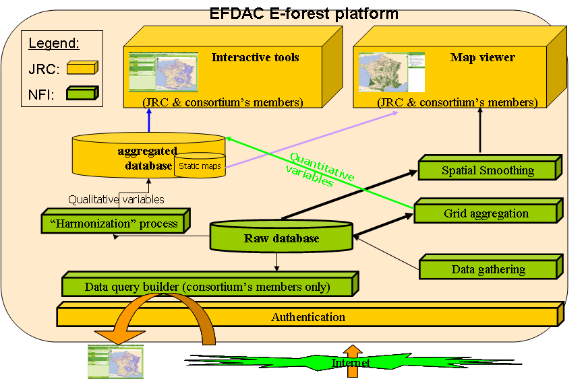

Database description

Overview

After the SC1, the platform was already using 3 database schemas :
- The raw_data schema : used to store the data sent by the countries.
- The metadata schema : used to describe the data and core of the system.
- The website schema : used to configure the website (user rights, …).
- The mapping schema : used to store cartographic information and layers.

For the SC2, we add 2 new schemas :
- The harmonized schema : where a part of the raw_data is copied in order to be accessible for the JRC.
- The aggregated schema : where the result of some aggregation process is stored in a static way.

Modules description

“Harmonization” Module

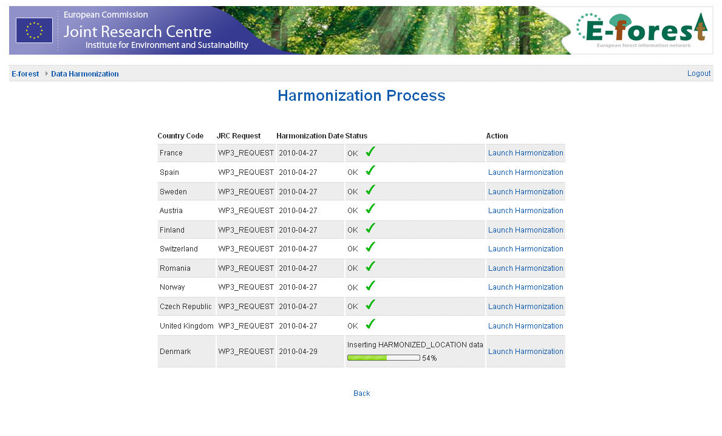

This module is used to copy the raw data to the harmonized schema and to pre-calculate some data tables in order to improve the performance of the aggregation module. This module does not concern quantitative variables but only qualitative variables.

The copy of the data is based, like the other parts of the system, on the metadata database. The “mapping” table describe which field should be copied into which column.

Note: The process of harmonizing the data, using some bridges country by country, could be plugged on this module in a future development.

The module is coded in java and deployed as a service in Tomcat. During the harmonization process, the web site asynchronously poll the service in order to display the progress bar.

At the end of the copy of the data, the harmonization module launch some SQL requests :
- It precalculates the cell identifiers for each raw-data location in the different grids available.
- It blur the position of the plot location. For the countries that have not already provided blurred location (flag is_plot_coordinates_degraded = 0), the module repositions the plot location to the center of the nearest 1km x 1km cell.

Grid aggregation module

The aggregation module calculates the average value of a quantitative variable (in SC3 only the basal is available) on a given grid cell.

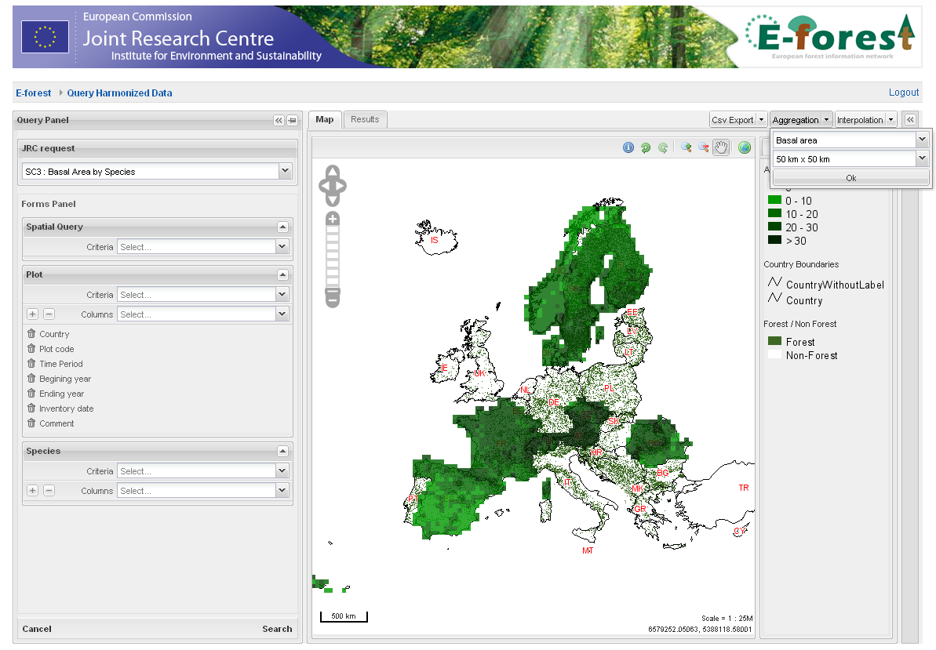

The module works using the plots selected by the user and add a filter on the plot belonging to the domain of the variable to aggregate.
In the case of the basal area, only the plot where the flag domain_basal_area = 1 are selected (it indicates whether the plot belongs to the domain in which the basal area is defined, see the plot data file description for more information).

The link between the selected variable and its domain is defined in the metadata database.

Aggregation parameters

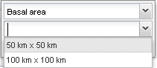

The aggregation module takes in parameter the name of a quantitative variable and an aggregation grid.

The list of aggregation variables is calculated by the system by examining the available quantitative variables used in the user request.

The list of available aggregation grids is defined as a configuration in the web site database.

Aggregation process

The module is coded in java and deployed as a service in Tomcat. During the aggregation process, the web site asynchronously poll the service in order to know when the new layer is available.

Once the calculation is done, the java module answers the PHP web site that the resulting layer can be displayed.

Aggregation layer

Once the layer is available, it is added to the list of available layers and activated by default. The layer depends on the session identifier. Thus, each user can build its own layer without visualizing those created by other users. This layer is not persistent, that means that after a logout / login operation, the aggregation layer is removed.

The definition of the classes for a given data is stored as a configuration in the web site database. The legend is generated dynamically according to the classes definition.

Aggregation result

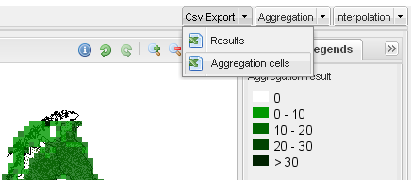

The result of the aggregation is stored in a temporary table and can be exported as a CSV file.

In the “CSV Export” menu, the “Aggregation cells” item is activated. It will generate a CSV file with the averaged value for each cell identifier.

Spatial smoothing module

The Spatial smoothing module assigns values to unknown plots by using values from usually scattered set of known plots. The value at the unknown plot is a weighted sum of the values of N known points.
It concern only quantitative variable (in SC3 only the basal is available) .

The module works using the plots selected by the user, exporting them in a temporary file and then running a R script corresponding to the selected interpolation method on it (currently only IDW is available).

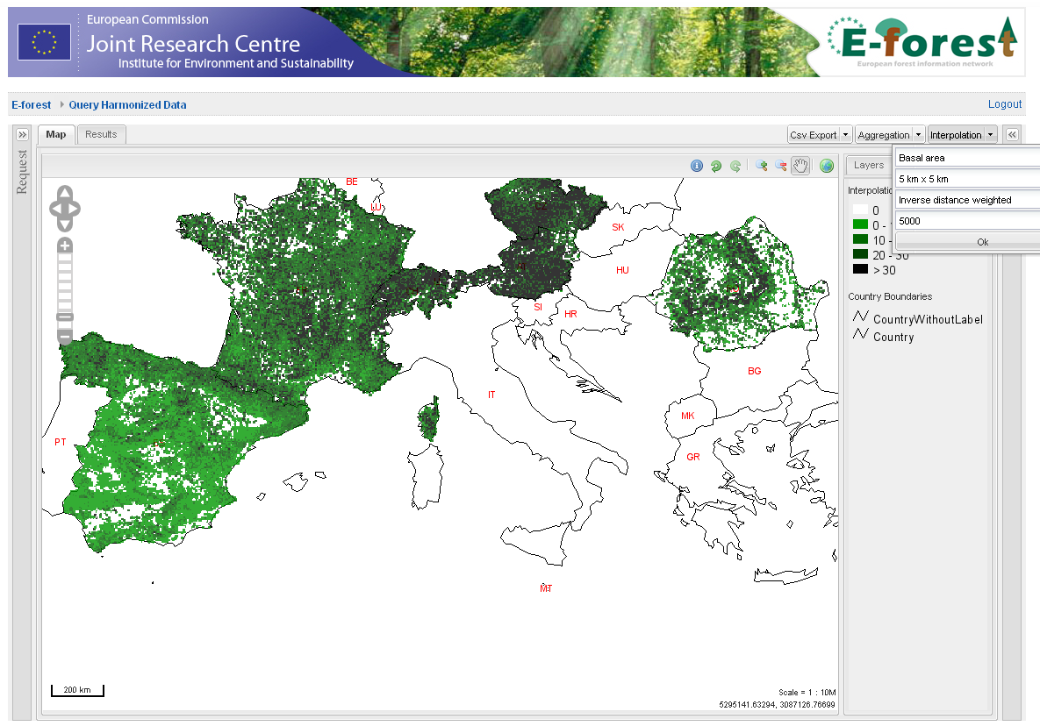

Interpolation parameters

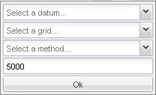

The interpolation module takes 4 parameters in entry:
- The name of the data to interpolate (list of all available quantitative variables)
- The grid used to do the interpolation (configured in the database)
- The interpolation method (currently only IDW is available)
- The maximum distance where nearby plots are taken into account (in meters)

Interpolation process

The module is coded in java and deployed as a service in Tomcat. The interpolation method is implemented as a R script.
During the interpolation process, the web site asynchronously poll the service in order to know when the new layer is available.

Once the calculation is done, the java module detects the end of the R process and answer the PHP web site that the resulting layer can be displayed.

Interpolation layer

Once the layer is available, it is added to the list of available layers and activated by default. The layer depends on the session identifier. Thus, each user can build its own layer without visualizing those created by other users. This layer is not persistent, that means that after a logout / login operation, the aggregation layer is removed

The definition of the classes is currently defined in the mapfile configuration (it is planned to generate it dynamically using styled layer definition, like for aggregation, but some bugs with mapserver raster configuration prevent us from having a clean legend).

Interpolation result

The result of the interpolation is stored in a file that is generated by R.

Note: The generated layer is only available for consultation and cannot be exported as a raster.

Difficulties encountered

Inland water

The inland water layer being not currently available in the platform, it has not been taken into account in the interpolation procedure.

Inspire Grids

We have encountered some difficulties to find a complete official reference for the INSPIRE Grids at 1 km x 1 km.

Some grids respect the naming convention but are incomplete for some countries some others are complete but have a different naming convention.

In order to have the more complete coverage, we have selected the grids having the more cells, but this means that the cell identifiers used in the system are not always easily identifiable.

Currently, this does not impact the aggregation module as we are using 50x50 km and 100x100 km grids but the “harmonization” module (used in SC3) can potentially move plot coordinates too far is cells are missing.

Interpolation performances

The interpolation module can generate some very heavy calculations, this depends on the number of plots selected and the number of cells of the resulting raster.

When all Europe is selected, with an interpolation at 2x2 km, the calculation can take half an hour.

In order to avoid limiting the responsiveness of the web site, it could be considered using a second server for interpolation calculations.

Follow up of the project, contractual steps

The foreseen planning presented during the kick off meeting

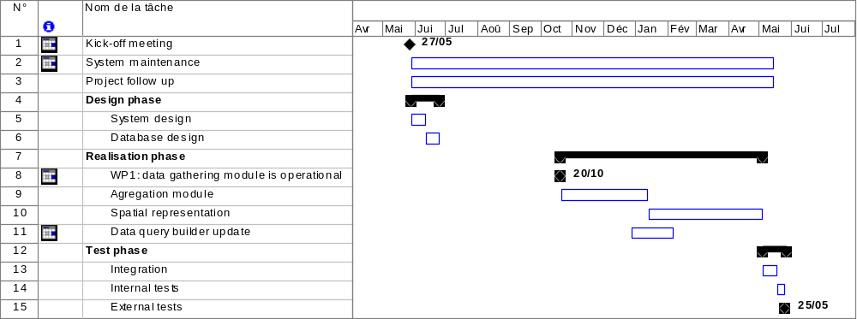

The main dates of the project are summed up below:
- SC2 :
- 27/05/2009 Kickoff meeting (contractual meeting)
- 10/09/2009: SC2 Progress Meeting
- 28/01/2010: SC2 Progress Meeting
- 18/05/2010: Final report (this document) sent to the JRC (contractual deliverable)
- Xx/xx/2010: Demonstration of the e-Forest platform (SC2)
- 10/06/2010: Final Meeting(contractual meeting)

